Task 1: Deploy zone-resilient Azure virtual machines by using the Azure portal and an Azure Resource Manager template

In this task, you will deploy Azure virtual machines into different availability zones by using the Azure portal and an Azure Resource Manager template.

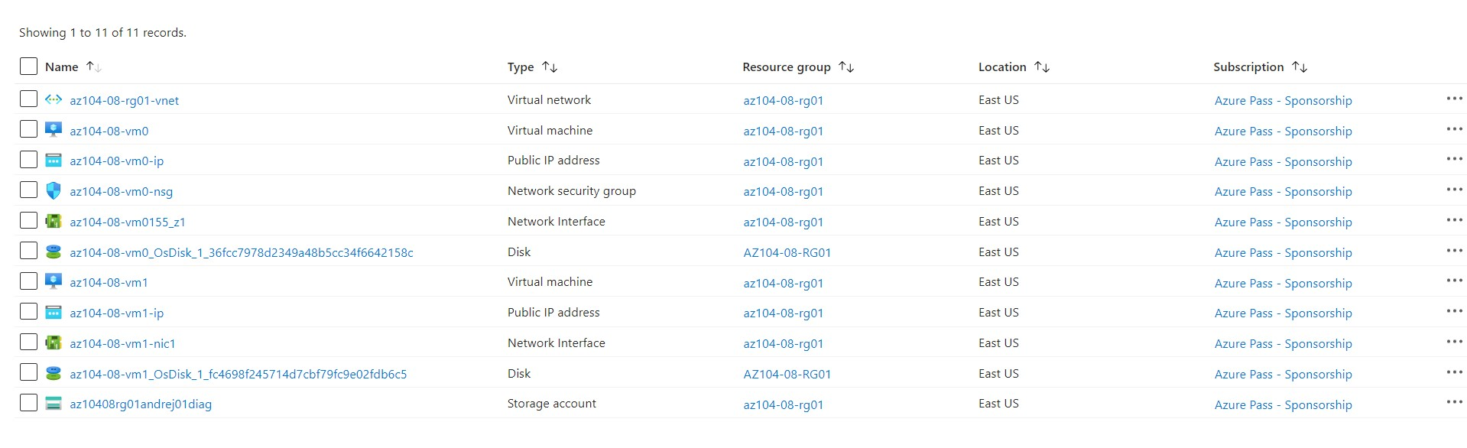

#### Task 2: Configure Azure virtual machines by using virtual machine extensions

In this task, you will install Windows Server Web Server role on the two Azure virtual machines you deployed in the previous task by using the Custom Script virtual machine extension.

1. on the storage account blade displaying the list of containers, click **scripts**.
2. On the **scripts** blade, click **Upload**.
3. On the **Upload blob** blade, click the folder icon, in the **Open** dialog box, navigate to the **\Allfiles\Labs\08** folder, select **az104-08-install_IIS.ps1**, click **Open**, and back on the **Upload blob** blade, click **Upload**.

-To verify that the Custom Script extension-based configuration was successful, navigate back on the **az104-08-vm1** blade, in the **Operations** section, click **Run command**, and, in the list of commands, click **RunPowerShellScript**.

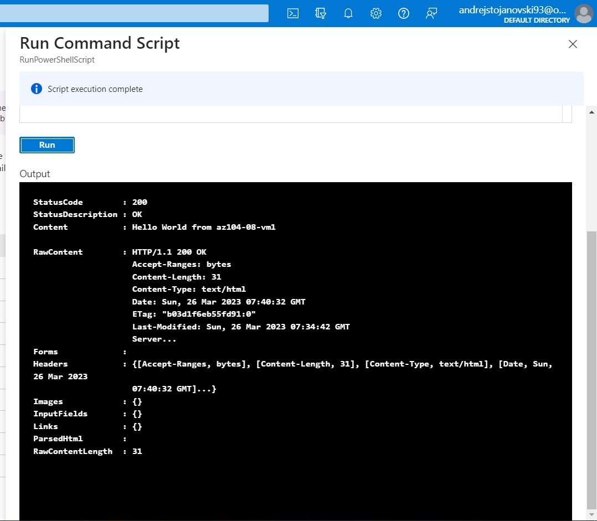

#### Task 3: Scale compute and storage for Azure virtual machines

In this task you will scale compute for Azure virtual machines by changing their size and scale their storage by attaching and configuring their data disks.

1. On the **az104-08-vm0** blade, in the **Operations** section, click **Run command**, and, in the list of commands, click **RunPowerShellScript**.
2. On the **Run Command Script** blade, type the following and click **Run** to create a drive Z: consisting of the two newly attached disks with the simple layout and fixed provisioning:

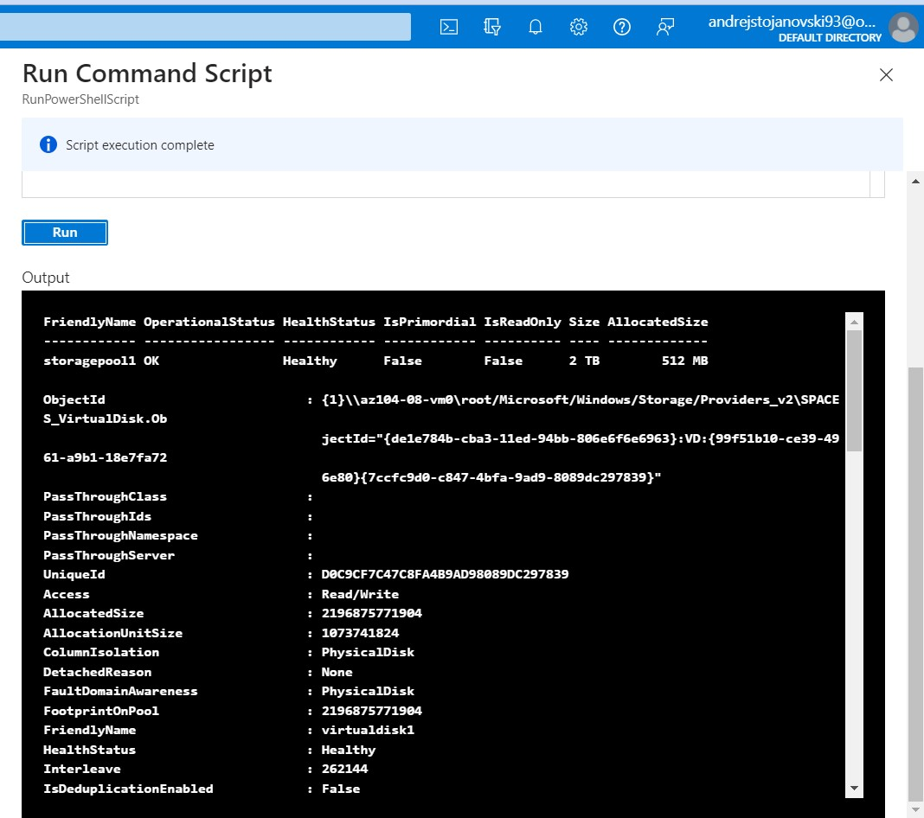

1. on the **az104-08-vm1** blade, in the **Operations** section, click **Run command**, and, in the list of commands, click **RunPowerShellScript**.
2. On the **Run Command Script** blade, type the following and click **Run** to create a drive Z: consisting of the two newly attached disks with the simple layout and fixed provisioning:

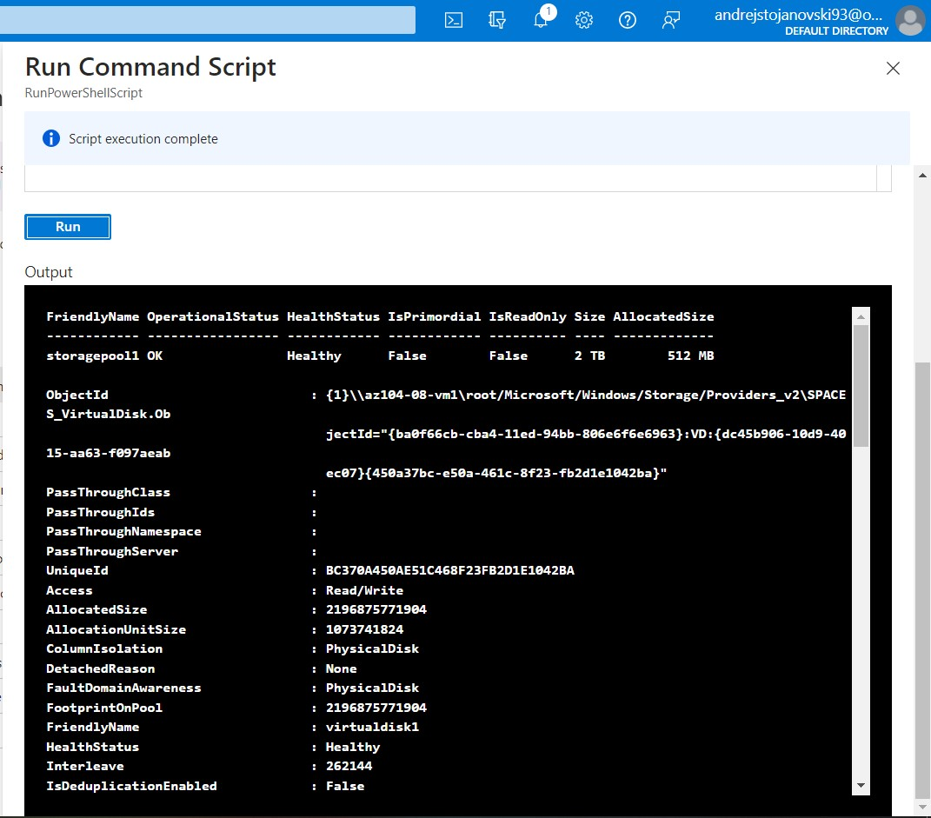

#### Task 4: Register the Microsoft.Insights and Microsoft.AlertsManagement resource providers

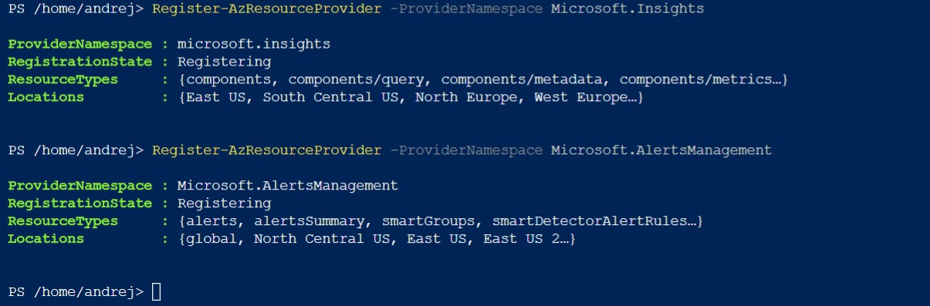

#### Task 5: Deploy zone-resilient Azure virtual machine scale sets by using the Azure portal

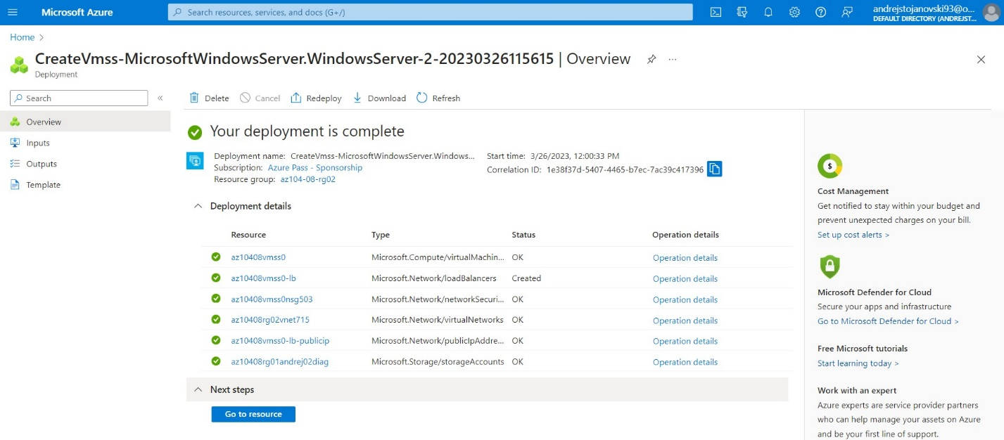

#### Task 6: Configure Azure virtual machine scale sets by using virtual machine extensions

In this task, you will install Windows Server Web Server role on the instances of the Azure virtual machine scale set you deployed in the previous task by using the Custom Script virtual machine extension.

1. In the Azure portal, search for and select **Load balancers** and, in the list of load balancers, click **az10408vmss0-lb**.
2. On the **az10408vmss0-lb** blade, note the value of the **Public IP address** assigned to the frontend of the load balancer, open an new browser tab, and navigate to that IP address.

**Note**: Verify that the browser page displays the name of one of the instances of the Azure virtual machine scale set **az10408vmss0**.

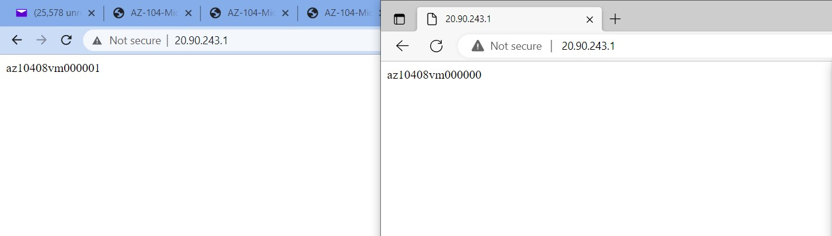

#### Task 7: Scale compute and storage for Azure virtual machine scale sets

#### In this task, you will change the size of virtual machine scale set instances, configure their autoscaling settings, and attach disks to them.

#### From the Cloud Shell pane, run the following to start an infinite loop that sends the HTTP requests to the web sites hosted on the instances of Azure virtual machine scale set **az10408vmss0**.

#### while ($true) { Invoke-WebRequest -Uri "http://$pip" } to trigger all instances

#### with different zone

#### 

#### 

#### 

#### In the toolbar of the Cloud Shell pane, click the **Upload/Download files** icon, in the drop-down menu, click **Upload** and upload the file **\Allfiles\Labs\08\az104-08-configure_VMSS_disks.ps1** into the Cloud Shell home directory.

#### 

1. From the Cloud Shell pane, run the following to excecute the script and configure disks of Azure virtual machine scale set:

./az104-08-configure_VMSS_disks.ps1